Correspondence
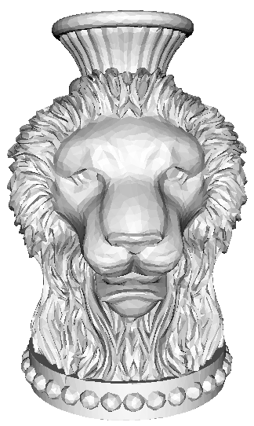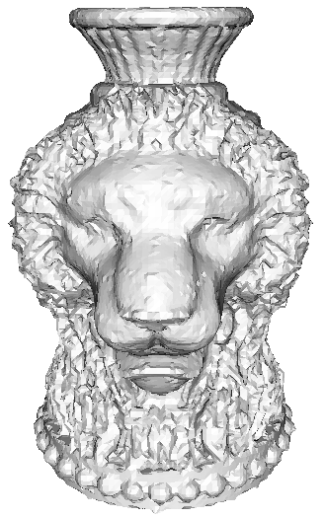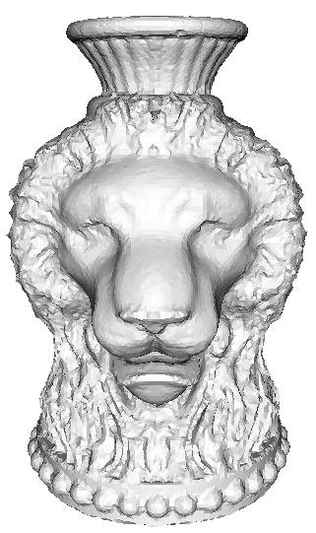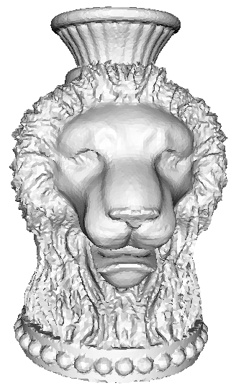
Original mesh non-obtuse (close) smooth (close) smooth (normal)
The correspondences based on closest point detection and normal direction hitting.

 | Max distance | Mean distance
Non-obtuse | 0.008423(0.012969) | 0.000504(0.001085)
Smooth | 0.007814(0.013810) | 0.000432(0.001284)
Smooth_normal hitting | 0.009495(0.011202) | 0.000256(0.000779)
The Hausdorff distances comparisions.

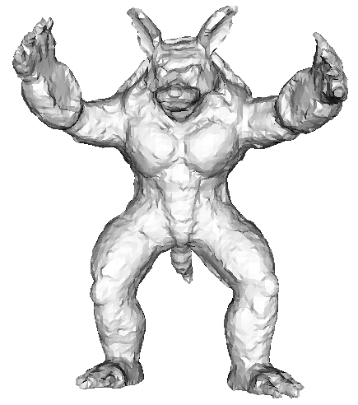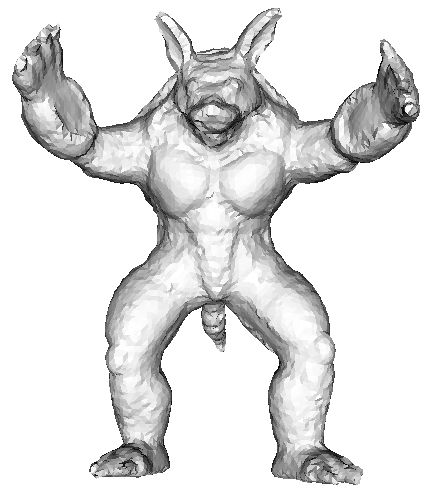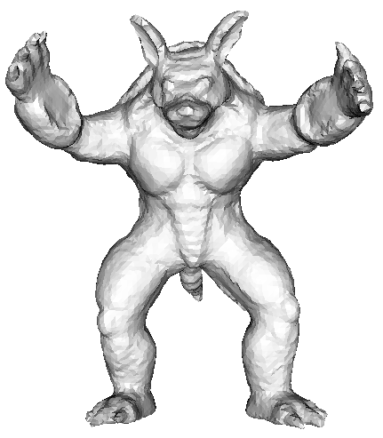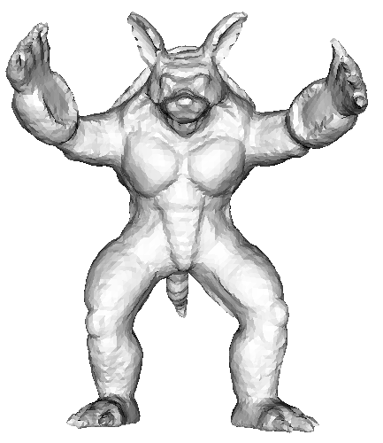
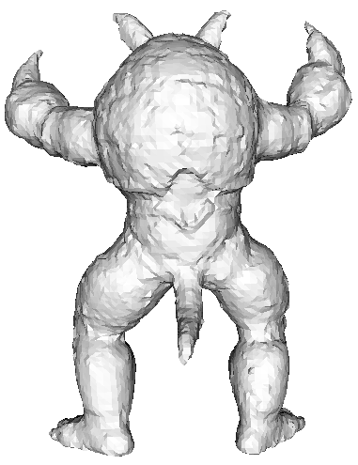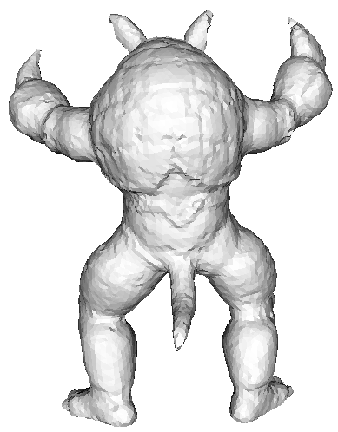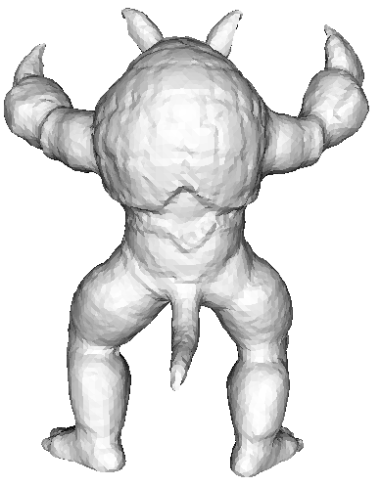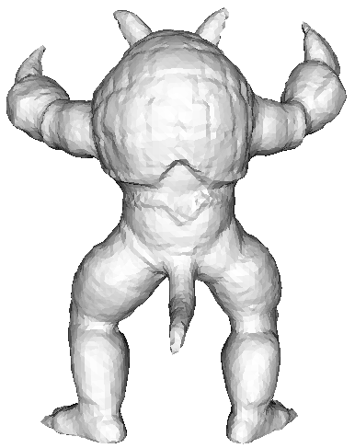
Non-obtuse smooth 1 smooth 2 smooth 2(normal)
The correspondences by the closest points and normal direction hitting.

 | Max distance | Mean distance
Non-obtuse | 0.008891(0.022927) | 0.000621(0.000992)
Smooth 1 | 0.013131(0.033493) | 0.000564(0.001238)
Smooth 2 | 0.008971 (0.030383) | 0.000441(0.001043)
Smooth 2 (normal) | 0.007818(0.015642) | 0.000275(0.000726)
The Hausdorff distances comparisions.

